System-Wide Requirements Specification – Appendix B – GUI Prototypes

1. **Login Window**

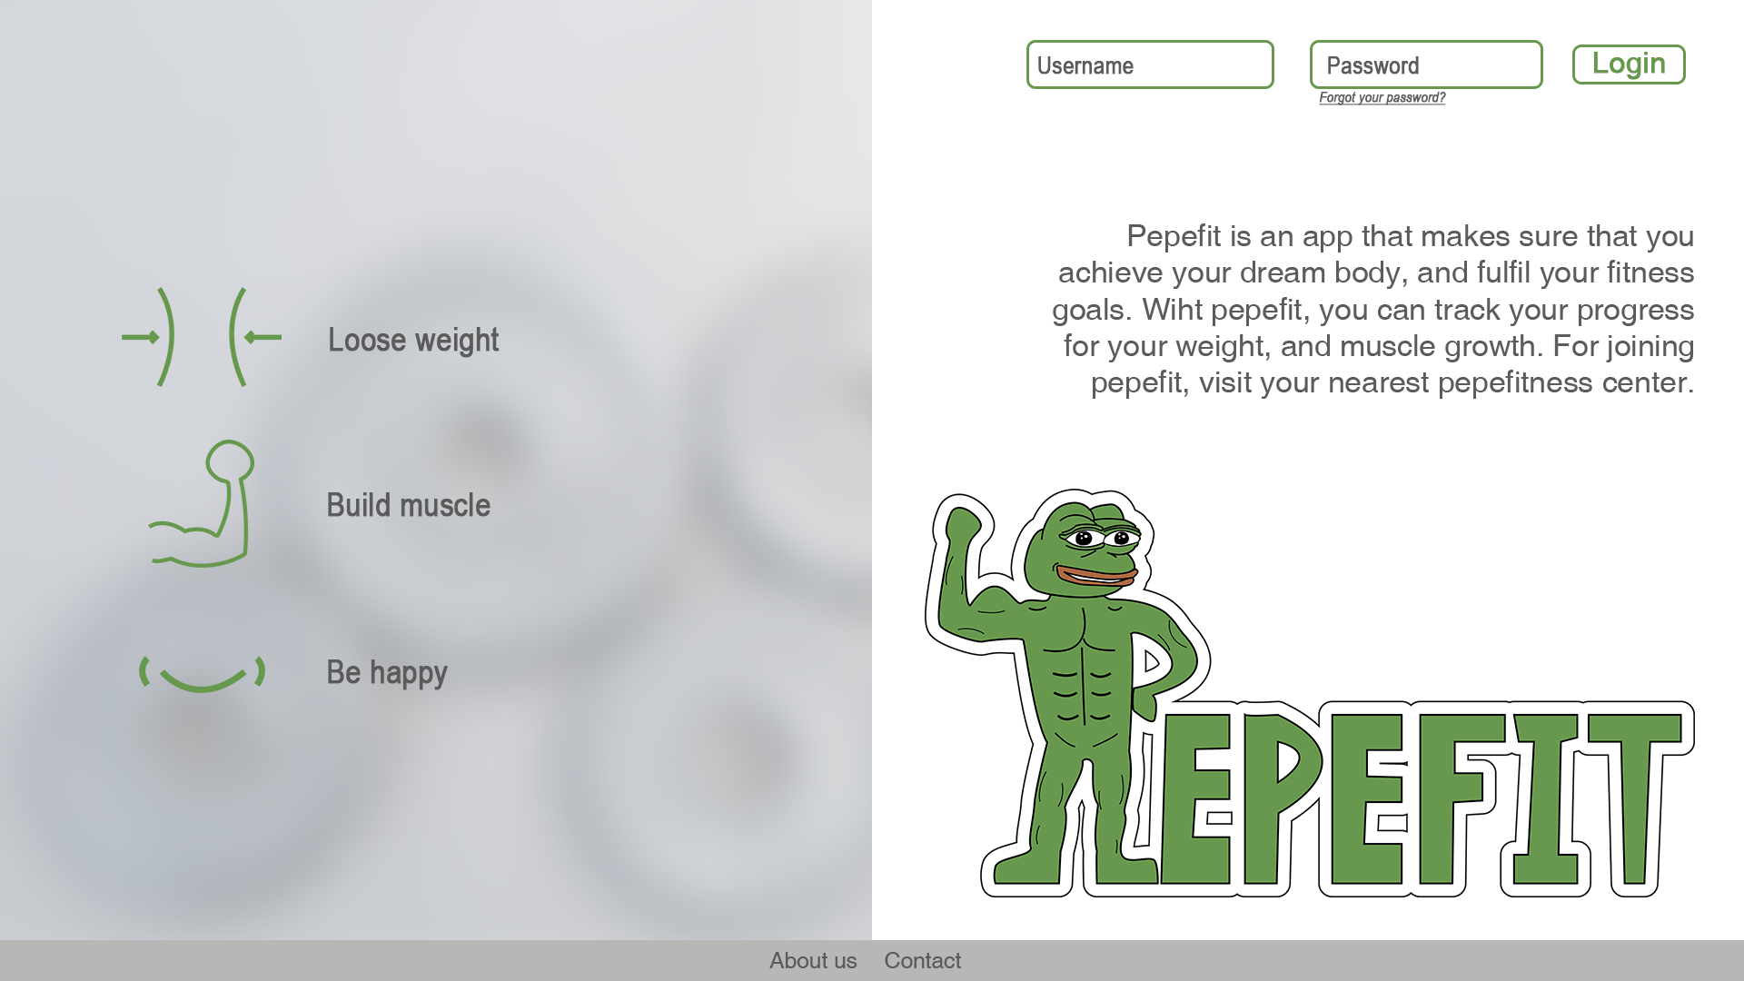

Related Use Cases:

* Use Case 1: Login

1. **View Courses**

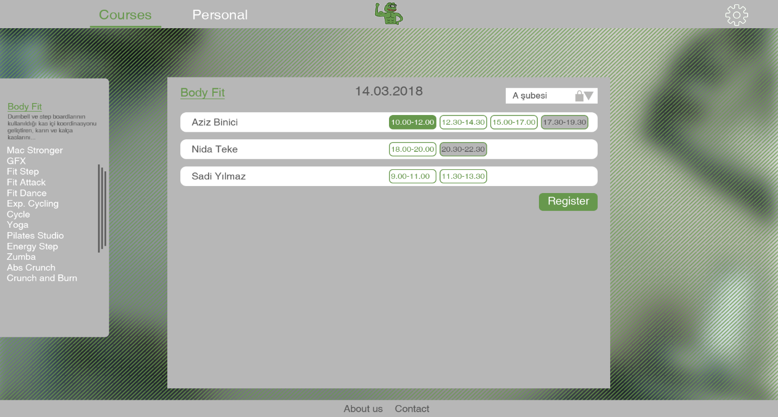

Related Use Cases:

* Use Case 9: Load Course

1. **Get Progress**

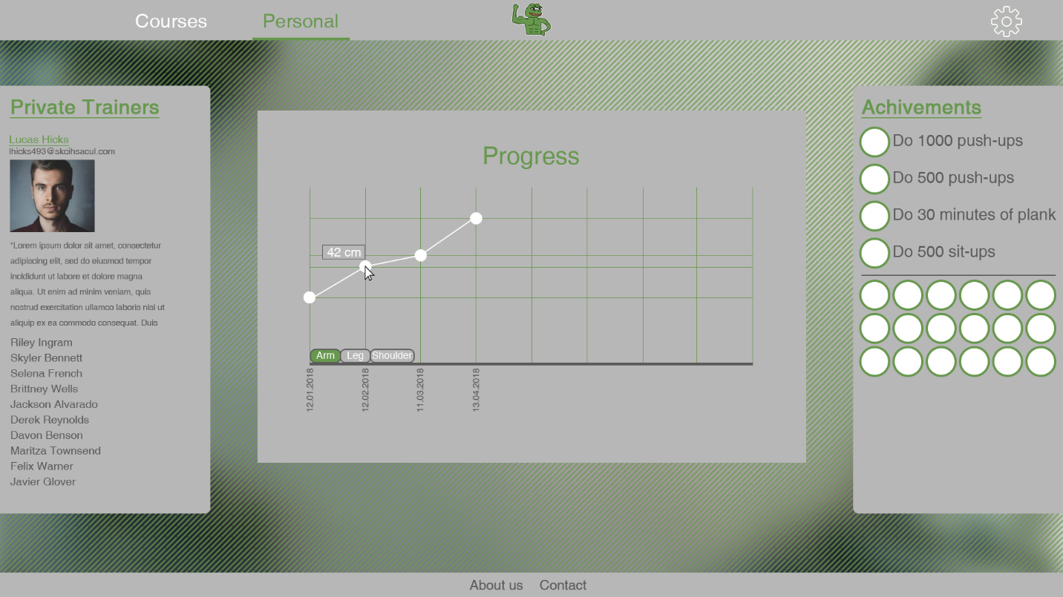

Related Use Cases:

* Use Case 4: Get Progress

1. **Add Course**

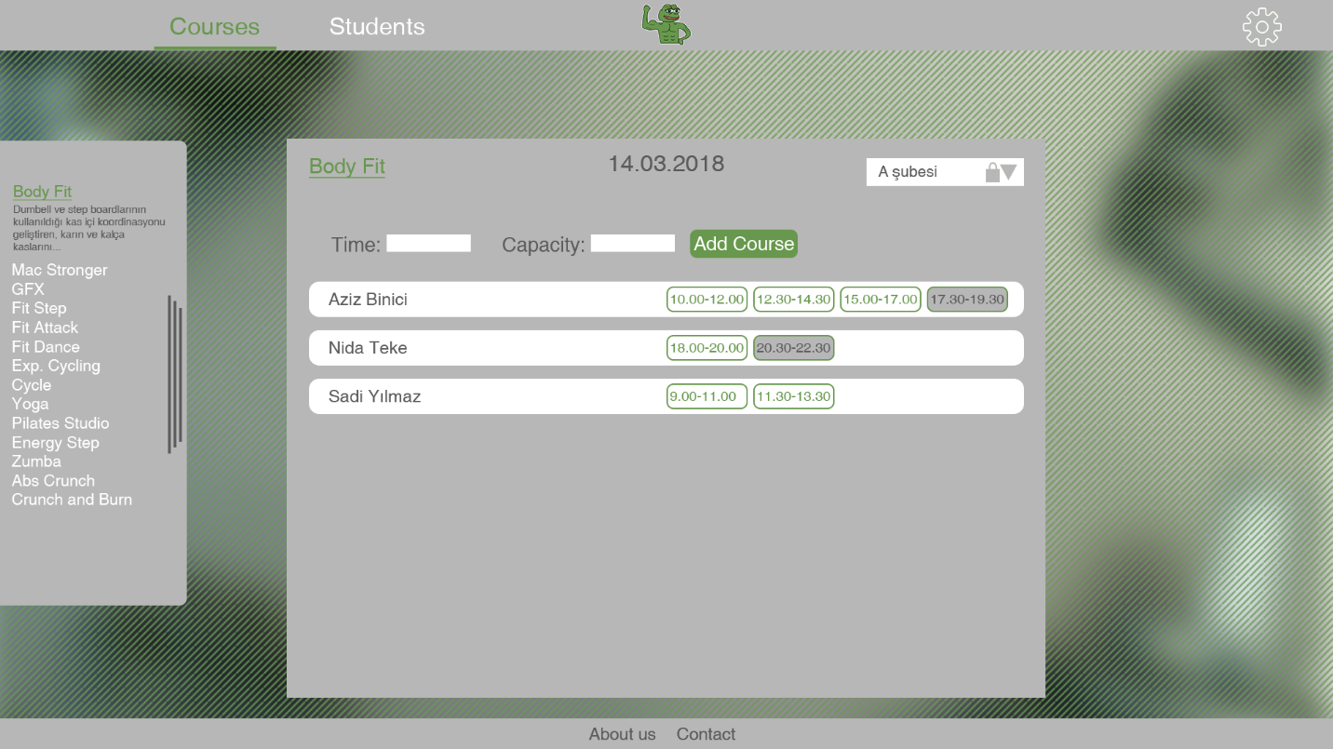

Related Use Cases:

* Use Case 8: Add Course

1. **Get Personal Data**

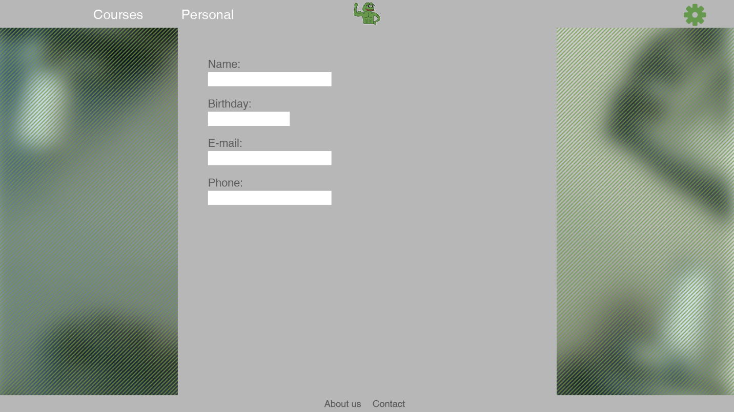

Related Use Cases:

* Use Case 6: Get Personal Data